APCM Reports

Oct 2020-May 2021

Due to the short amount of time from the last APCM and the restrictions put in place due to Covid 19, these reports are shorter and fewer in number than might usually be expected.

Church Wardens Report – All Souls.
It is about seven months since the last APCM and Churchwardens’ Report. Throughout the whole of this time , we have been in various stages of Lockdown, the final one in January which has curtailed out Parish activities somewhat.
All Souls’ Church , continued throughout Autumn 2020 with virtual services, Morning Prayers, Sunday School and Toddler Praise each week. Our knowledge of technology has increased tremendously thanks to Zoom and video Services. Our thanks for this go especially to Stephen and Rachel and also to Aled and others who work the Power Point on the computer for our services. Mary has continued to co-ordinate those who keep in touch with parishioners and the virtual Prayer chain. We have benefitted greatly from Stephen and Sarah Mortimer’s Ministry .From January, they have been joined by Vusi Mabuza from South Africa and we have embraced and enjoyed his style of worship and ministry.
We welcomed Fay Philp as our Administrator in October and she is a welcome addition to the team, being involved with bookings for the Church, Village Hall and the Scout Hut. We anticipate these will be used again by groups as venues are opened up gradually for hire as Lock down is eased. I have, once again, joined the Church team as Churchwarden with Aled Jones. Fiona and Keith Thompson along with Arabella Cameron have also joined the All Souls’ team with the Ministry team led by Stephen with Sarah and Vusi.
Our new organ is competently played each Sunday by our organist and pianist Judith Usher, who was able to gather a small choir for the Christmas Services. Our Christmas worship was well attended considering we were in a Lockdown situation, as were the Easter Services. A youth Service, Ascot@4 has resumed , led by Tim Norman and our curate, Sarah Mortimer. It is hoped that the group will flourish and grow in numbers, and already several members of the group have recently been Confirmed.
The Lady Chapel enclosure is currently on hold as the new heating system needed is in hand and will, hopefully, be installed by the Autumn. All Souls’ continues to be open daily for private prayer from 10am to 4pm as a community asset and thank you to those involved in the opening up and closing of the premises daily.
From January, a Sunday Service was held alternately at St Michael’s and All Souls’ and these were regularly attended by those who felt safe abiding by the Covid-19 social distancing protocols. However, we are now back worshipping as before with Services in both Churcheson Sunday mornings, one of which being live- streamed.
We were delighted that Liz Moore and Geraldine Lecky were able to open up the Coffee Shop in April 2021 -another valuable community facility-with tables outside. The Art Group resumed there too on Tuesdays, but since May 17th, both are now back in Church.
Sadly ,Kim and Tim Bastock moved away last Summer and we miss their Spiritual and musical input in our Sunday Worship.
A small sum of money was sitting in the Gambia account and together with a generous donation, money was transferred to the Schools and Churches which we support, as we felt it was of use to them now.
We are very grateful for donations towards running All Souls and this can be done by direct Debit, by card on the machine in Church ,on –line or by speaking to a member of the Church team. Volunteers are always needed in the Coffee Shop and we are always looking for people who would be willing to join our Church team. Do speak to any of the Church team if you would like to help in any way. We welcome and value your continued support.
Sandra Stansfield and Aled Jones
Churchwardens

Churchwarden Report – St Michael & All Angels Church
At the last APCM on 19th October, we were still looking forward to being able to see family at Christmas, even though another rise in Coronovirus cases was happening, leading to a four week national lockdown announced on 31st October.
Our Church had been open and services had been taking place with reduced attendees and with services being livestreamed (alternating with our sister church All Souls) to meet the needs of those who felt they would rather not mix even with Covid rules such as masks, hand sanitising and social distancing very firmly in place and no singing in the Church.
A tremendous effort by the Vicar and the Choir, led by our Musical Director Camilla Jarnot, meant that in December we had two well attended Christmas Carol Services outside the Church – utilising the car park for the first time as part of the Church premises. It was a joy to sing outside and be together, even if we were all in our bubbles as painted on the ground!
Sadly, the emergence of the new Kent variant meant that Christmas with families was cancelled on 17 December and we effectively returned to lockdown.
We were blessed that churches did not have to close this time and the PCC took the decision to be as safe as possible and have one main service on a Sunday, alternating between St Michael’s and All Souls and being live-streamed, with Family and children’s services returning to on-line delivery. This was our routine until Easter (4th April) when we gloriously returned to Sunday services in each church and Family Service resumed at St Michael’s.
During the early months of 2021 the Vicar and Camilla introduced Zoom meetings where people could join in singing hymns – with individuals muted so it was a very personal experience! – and these were very much enjoyed. So we introduced singing outside before services moved indoors and this too was a joyous return to musical worship at St Michael’s.
So here we are at the end of May – Family Service and the main 10.45 are split between outside and inside (depending on the weather!) but with the wonderful vaccination programme meaning vast swathes of our congregation have received not just one but both jobs, more and more people are returning to Church services and it is so lovely to welcome them back.
Weddings are re-starting and our Hall hirers are returning.
Thankfully our beloved Church building has not caused us any problems during the last six months but I am deeply grateful to Cliffe Chermside for once again leading us in our Quinquennial Inspection (delayed from 2020) when we will learn what needs to be done to keep the building healthy and safe.
Our Curate, Sarah Mortimer, has done fantastic work in setting up a whole series of events for Thy Kingdom Come (between Ascension Day and Pentecost). Her enthusiasm and commitment are very much appreciated. We are very excited that on 27th June she will presiding at her first Communion.
This APCM will be the last for our Vicar, Stephen Johnson. For the past 12 years he has been a wonderful leader, preacher, pastor, musical maestro, technical wizard and so much more. We will miss him, Rachael and the whole family very much. They go with our love and best wishes, and we hope to keep in touch and hear of more great achievements in his new Parish. We look forward to celebrating his time with us before he leaves at the end of July.
The St Michael’s Team members will now join with other PCC members in starting the recruitment process and, for however long it takes, keeping our Church alive and delivering to our congregations and our community the good news of Jesus and of God’s love. We have our God, faith and hope and we look positively to the future.
Vanessa Cummings
Churchwarden of St Michael & All Angels

Electoral Roll.

Last year I reported that the number on the Electoral Roll for St Michael’s was 196 and that for All Souls’ was 66, giving a total for the Parish of 262. The figure for St Michael’s this year is 194 and that for All Souls’ is 63. The total figure for the Parish this year is therefore 257.

Nicola Hughes
Electoral Roll Officer

Carols on the Green – 2020

This was changed this year from the Green to the car park between the Scout Hut and the Church Hall and was well attended with people standing in their family groups socially distanced.

Fiona Jones

Report on Ladies’ Fellowship
Although we haven’t been meeting over the past 14 months, the ladies have kept in touch by phone, email and letter. A few of us have ventured to Church, but most have felt safer by staying away.
This has kept us well connected and we look forward to joining up in the hall on July 1st for a celebratory re-union!
I hope to do a recruitment drive, to encourage new members, for when we meet again in earnest in September.
Stephen has kindly arranged to give us Holy Communion on both Thursday 10th June and Thursday 8th July at 10.30.
Pam Cross

Report on Parish Magazine
Keep calm and carry on! That has been our motto over this humungous year of restraint, and thanks to our great team of writers, advertisers, deliverers and readers, your magazine has survived the ups and downs of the past 12 months or so. First, a big thank you to those stalwart few who kept the magazine in circulation during the first few months when we weren’t even able to ask our normal band of 100 or so deliverers to send out door to door. But we have managed to get that aspect back on track. (see George Spinks’ letter in July/August edition regarding the trials and tribulations of delivering!)
The income from our advertisers has dipped slightly (as many of them have their own troubles), and we haven’t been able to include leaflet distribution which brought in useful extra income, due to not being able to gather enough “stuffers” together to carry out this labour intensive task. However, we plan to resume this service with the July/August magazine. And talking of distribution, we are delighted to welcome Lyndsey McNair who took over this task from yours truly at the beginning of 2021. Also, since our last we welcome (belatedly) our new Advertising Manager, Emma Gibson, who signed up for this key task last summer. She has been doing some sterling work, and although you may not have seen her (photo is in the mag) she has been wooing and cajoling our advertisers from her home in Virginia Water, and I can assure you that she is a potent weapon in our editorial armoury.
Great thanks must go to our energetic compositor Roger Kohn, whose eye for design and creative imaging has kept our magazine in the forefront of UK Church Parish magazines for many years now (we always come close to top in the Annual Parish Magazine Awards which covers over 700 magazines in the UK)
And finally, …… my heartfelt thanks to the ministry team and everyone in the parish for continuing support and devotion including the occasional letter or phone call of appreciation, which drives us on to continue to produce, as Carlsberg might say, probably the best Parish Magazine in the World! (Well, we think so anyway). Mike Cross
Report on Thursday Discipleship Group
In the world before Covid lockdown in March 2020, we were a thriving group of between 8 and 12 participants keen to learn from each other about the faith that we share, and sometimes have difficulty with, meeting every Thursday evening in St Michael’s Church Hall. After the government edict to retreat to our homes and ne’er breathe on another living soul, we continued to meet virtually on Zoom. From that time, although we continued to talk to one another, I noticed that a) the numbers were diminishing and b) that the quality of our exchanges seemed also to diminish. I certainly thing that, useful as online meetings are, they don’t allow the bounce back and forward of ideas and doubts that happens during face-to-face meetings. So, I decided to give it a rest over the Christmas period, and although we all exchanged New Year Greetings on WhatsApp, we haven’t met since then, although Varsha, bless her, has been keeping us up-to-speed with Bible quotations at regular intervals! Thank you Varsha for your commitment! I would love to keep the group going as I strongly believe that the growth of any church is seeded in great part by small groups exchanging ideas and underlining their faith. I would like to restart the group after the June 21st (freedom day) so would propose re-convening live in the Church Hall on Thursday June 24th at 8pm. Please let me know if would like to join us. You can reach me on 07737 088 423 or mike@mike-cross.me.uk
Mike Cross
Parish Care Network
The team from the PCN has not been able to meet but everyone had a list of phone numbers that they could ring and there has been a lot of telephone communication. Both churches initiated phone buddy systems and contacted everyone on the Electoral Roll at various times. I have been in touch with the Phone buddies who have also been calling around. Some people have preferred not to receive calls and others have appreciated communication frequently. We have shoppers and helpers willing to help out where needed.
Mary Nichols
Toddler Praise
We are a friendly and very lively group that meet every Tuesday at 10.30am.
The service is specially designed for babies, children and their parents or carers - it is simple & short.
Our session begins with a craft activity followed by a Bible story to help us learn about God.
We have lots of fun as we sing, dance and pray together.
We also meet during the school holidays and look forward to welcoming older brothers & sisters back to visit us.
To summarize - it's an exciting time of talking, sharing and listening to each other as we grow in our faith and learn more about our incredible God.

Numbers vary from week to week – we have 6 regular families
During lockdown we have been meeting on Zoom – we sing & have a story, pray & share with each other.
When restrictions were eased we met in Church for a few weeks, however back to zoom in the new year.

Not everyone is still comfortable to meet inside, so on the 27th April we decided to meet in the garden of the Scout hut to have our service face to face, obviously it's not perfect as we have battled against wind, hail, & rain – we are still waiting for the sunshine, but we are covid safe.
Nicola Shaw
All Souls Sunday School
In normal times
All Souls SUNDAY SCHOOL meet at 10.30am every Sunday - except the 1st Sunday in each month, when we celebrate 'Cafe Church'
Aim :
To teach the Children to pray
To worship in a happy & fun environment
To prepare the children for normal Sunday worship.
To encourage them to grow spiritually
& find a deep faith that will help them through the teenage years and into adulthood.
We have fun activities, a time of worship, Bible stories, drink & biscuits and crafts - plus a time to share thoughts and feelings.

DURING LOCKDOWN
During the last year Sunday school as been on zoom & taken a new form.
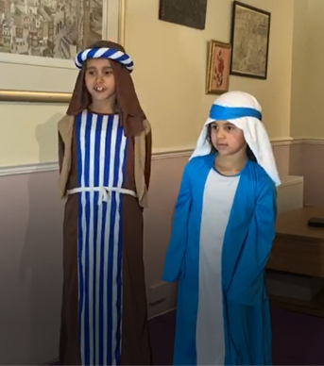
I Email the worksheets & the Bible readings with names next to each verse so every child (5 – 12 years) can read & take part.
Numbers have been consistent with 7 children joining each week.
We follow the same Bible readings as the congregation.
We discuss what the passage means & how we can learn from it & put it into practice in our own lives.
It's been exciting seeing these young lives develop & grow in Jesus,
I am so proud of William & Zeethan who were confirmed 23rd May.
I would also like to thank Sandra (Church Warden) for joining our sessions each Sunday & leading when I'm not available. She brings support, knowledge & her own story of faith to share.
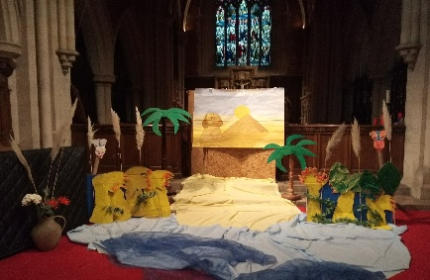
The NATIVITY
At Christmas we still managed to do our Nativity play. A nearly prefect traditional version with one minor alteration, a female Herod.
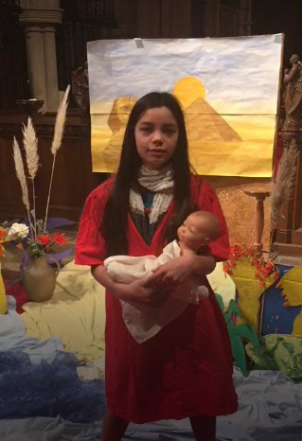
We have 3 families who attend our Cafe church service who always take part in our plays along with our Sunday school children.
Each child was given a part & costumes & their parent filmed their performance.
A big thank you to Stephen the Vicar for creating each clip into an amazing short film, which was shown during our Sunday morning service.

THE CRIB SERVICE is an important part of All Souls worship, Thanks to Stephen & his technology ability.
We filmed this service with the Children taking part but each child came into the Church separately so we were Covid safe.
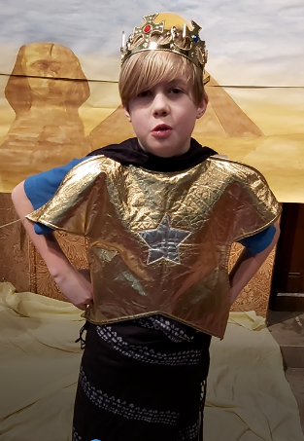
Stephen then pulled it all together & it went out Christmas Eve.

MOTHERING SUNDAY
Also this year we managed to do a play especially for Mothering Sunday - Moses in the Bulrushes.
This time each child separately went into All Souls church to be filmed by their parent.
We had staged an Egyptian scene for this
This time it was thanks to Sarah our Curate who brilliantly combined the clips into a short film for us.
It was amazing please - see the website for both these plays

GOOD FRIDAY
The Sunday school children took part in filming on zoom the bible reading for this brilliant Good Friday service especially for young people.
Nicola Shaw
1st South Ascot Scout Group – September 2020 – May 2021

The 1st South Ascot Scout Group is delighted to have all the works finished on renovating the new hut. The number of children attending the group is increasing and in April we opened a new Explorer Unit for 14-18 year olds.
We now have 14 leaders across Beavers, Cubs and Scouts with over 75 children and 1 young leader.

The Scout Hut
One of the main issues facing the Group was the hut on Church Road had no heating (as the dangerous old gas heater which hung from the roof was removed in 2018). This meant that the hut was freezing during the winter months as there was no insulation in the hut building. There were many holes within the wooden cladding, broken windows and ill-fitting doors plus a leak in the roof.
The hut has now been fully insulated, re-clad, with a new roof, new stairwell up to the mezzanine level, re-painted, new heating, new external lighting, new soakaway installed, new fence along the boundary with the graveyard and a new fire-pit has been installed. Ascot Racecourse were very generous and planted trees and re-grassed the garden for free.

Fiona Jones was awarded the Chief Scouts Commendation for Good Service by the Scout Association.

Scout Activities
The groups have continued to meet via Zoom with the amazing leaders putting on a varied programme. The Group has planned a Fun Day with Sunningdale Scout Group in July and a Fun Day in September for all members of the group to attend and take part in caving, climbing, archery etc. We look forward to camping again next week.

2021 - 2022
The security needs to be improved with a new fence along Church Road. The garden needs a patio by the rear entrance to the Hut. We are also hoping to be able to rent out the space to generate an income for both the Scouts and the Church.
Fiona Jones

Girlguiding South Ascot
Guiding had to stop meetings quite suddenly in March 2020 when lockdown began.
Some units took a break from activities, others sent out activity packs either by email or by post and others met on zoom.
All camps and holidays had to be cancelled including WINGS- the international camp that is held every 5 year in Windsor Great Park and is a once in a lifetime event for many.
In the autumn term we were able to meet outside for a while which some units did until we were locked down again so continued meeting via zoom in some cases.
Since April we have been allowed to meet outdoors and now indoors whilst adhering to Covid19 guidelines and very indepth risk assessments!
Numbers have fallen in some units which in a way is useful when it comes to social distancing and managing a different way of Guiding but if things continue to improve, we are sure our numbers will increase once again.
We are indebted to our volunteer leaders who have kept going through very trying circumstances whilst managing their own personal family situations.
We are constantly on the lookout for more leaders to help out so if you are looking for a new post-covid activity, please get in touch!
Ruth Bannerman

